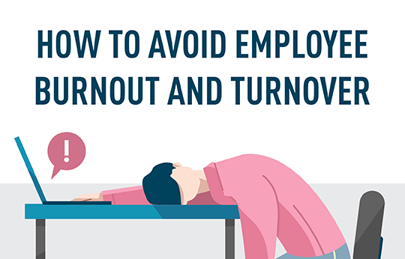

How to Avoid Employee Burnout and Turnover:
Hire and Train High-Quality Managers
by:

The unemployment rate still hovers around 3.7% as of October 2019¹. Employee retention and engagement remains a top priority for many companies. According to a recent Gallup survey, 85% of employees are not engaged or actively disengaged, which ends up costing the global economy up to $7 trillion in lost productivity². To assess employee engagement at your staffing company, evaluating metrics behind employee burnout and turnover is a good place to start. Here are some recent statistics regarding the effects of employee burnout in the United States:
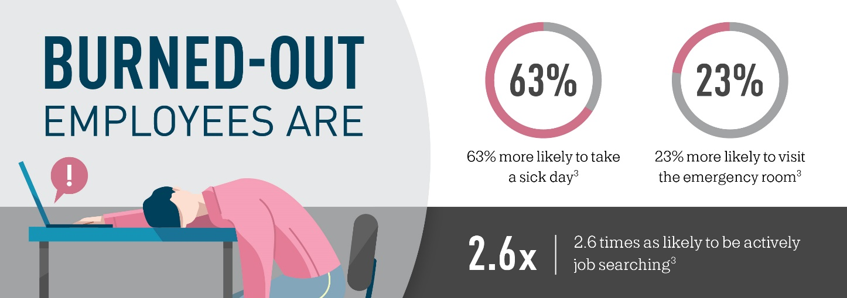

Link Between Burnout and Managers
As others dig into this topic, surveys have found a good predictor of burnout across many companies. One of the most accurate predictors of whether employees become burned out is based on their manager. Here are a few key statistics about the link between burnout and managers:
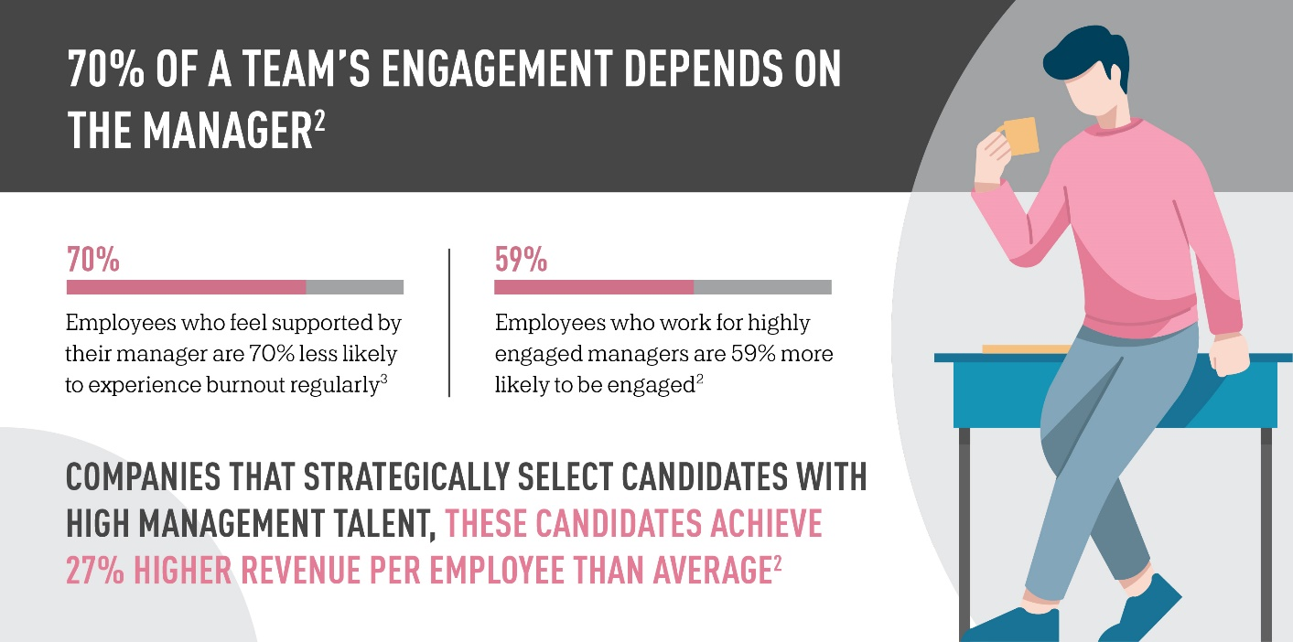

Avoid Employee Burnout and Turnover

Helping employees avoid burnout significantly impacts a company’s productivity and efficiency levels in a positive way. As a first step to increasing employee engagement and reducing burnout, companies should focus on training their management team and hiring candidates with management talent and skills.

For staffing agencies, figuring out how to keep temporary employees engaged can be even trickier than the average company. If your staffing agency is looking for new tools to engage temporary employees, check out TempWorks Buzz, the staffing industry’s first native app for employee engagement. In addition, staffing agencies can also choose to use the geofencing and facial recognition features within TempWorks Buzz to streamline the punch in and punch out process for employees at the worksite. Contact us for more information on how to engage your employees with our mobile solutions!

Sources:
- Bureau of Labor Statistics, Labor Force Statistics from the Current Population Survey
- Gallup, 2018, Want to Improve Productivity? Hire Better Managers
- Gallup, 2018, Employee Burnout, Part 1: The 5 Main Causes

